**PAS**

**To:** Dr. Matt Bohm

**From:** PAS

**Project:** Plasma Arc Speaker

**Subject:** Concept Variant 1

**Date:** March 4, 2011

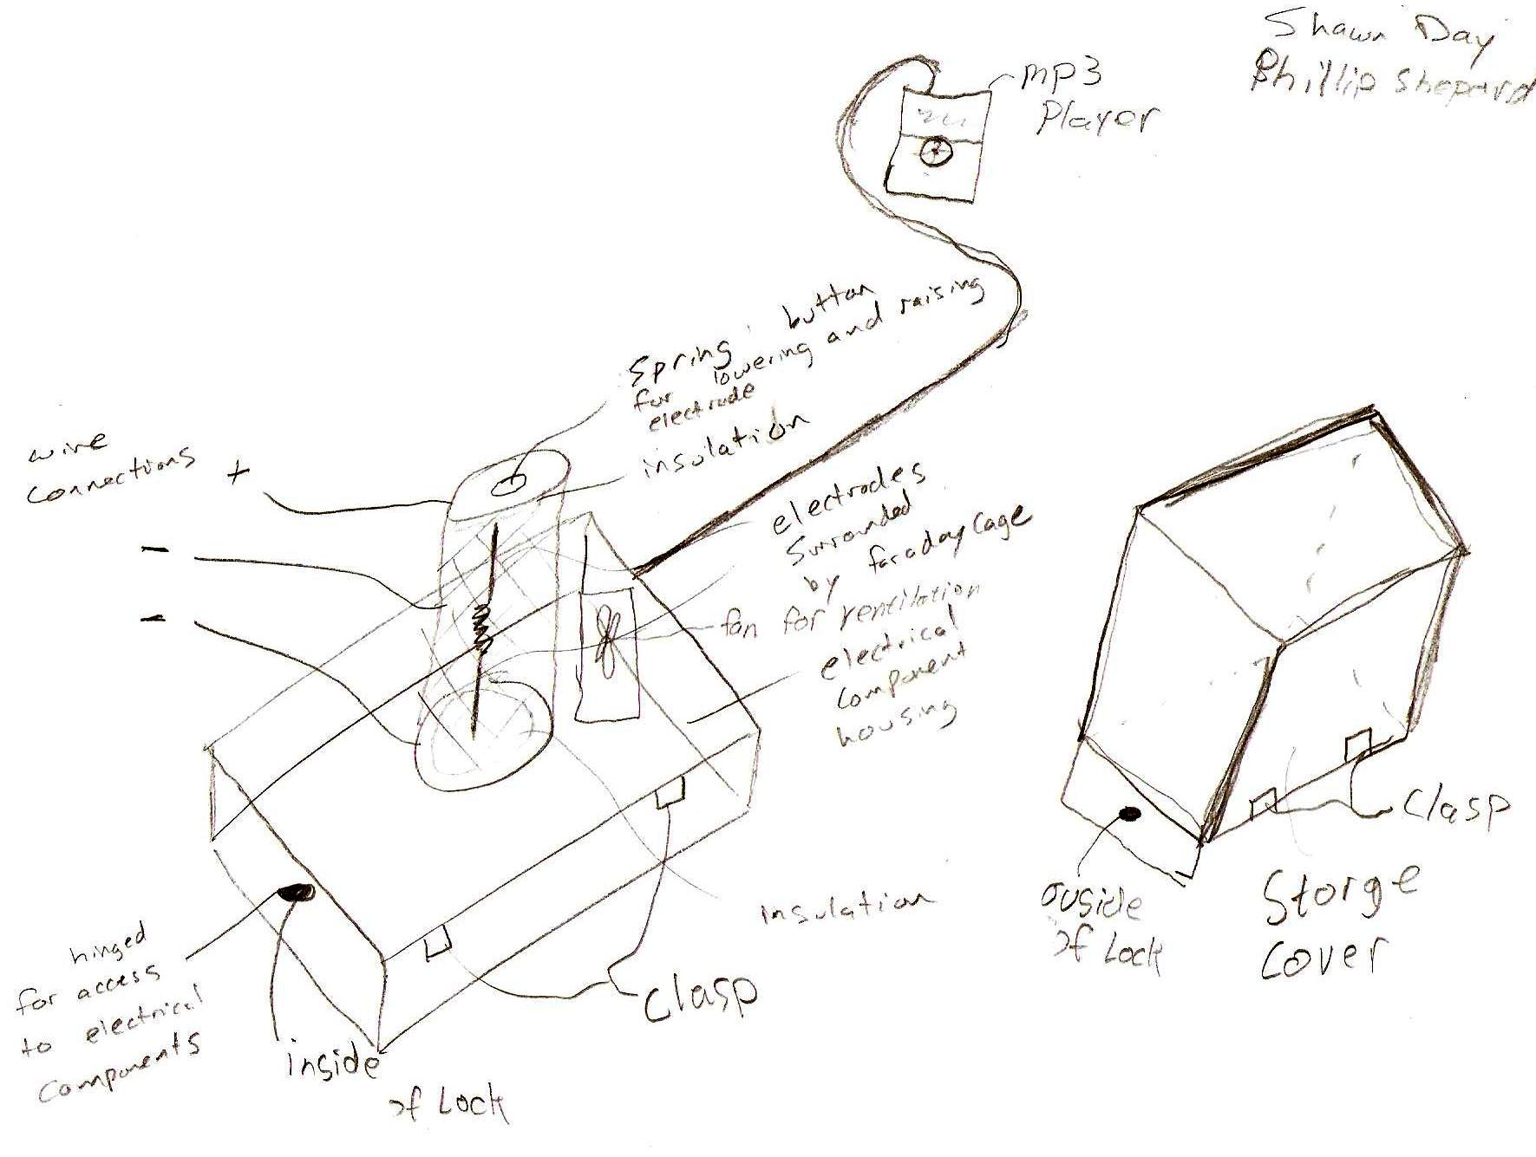

CV 1 houses electrical components in the bottom box, with a fan for cooling and hinged door for easy access.  The vertical electrodes above the housing are insulated from contact on the top and bottom with wood or a ceramic material and are surrounded by a Faraday cage. This design allows for 360 degree sound distribution.  The top electrode is connected to a spring with a button on top to press to lower and raise the electrode for initiating and optimizing the arc.  A cover with clasps for latching onto the bottom housing is shown for protection when the speaker is not in use.